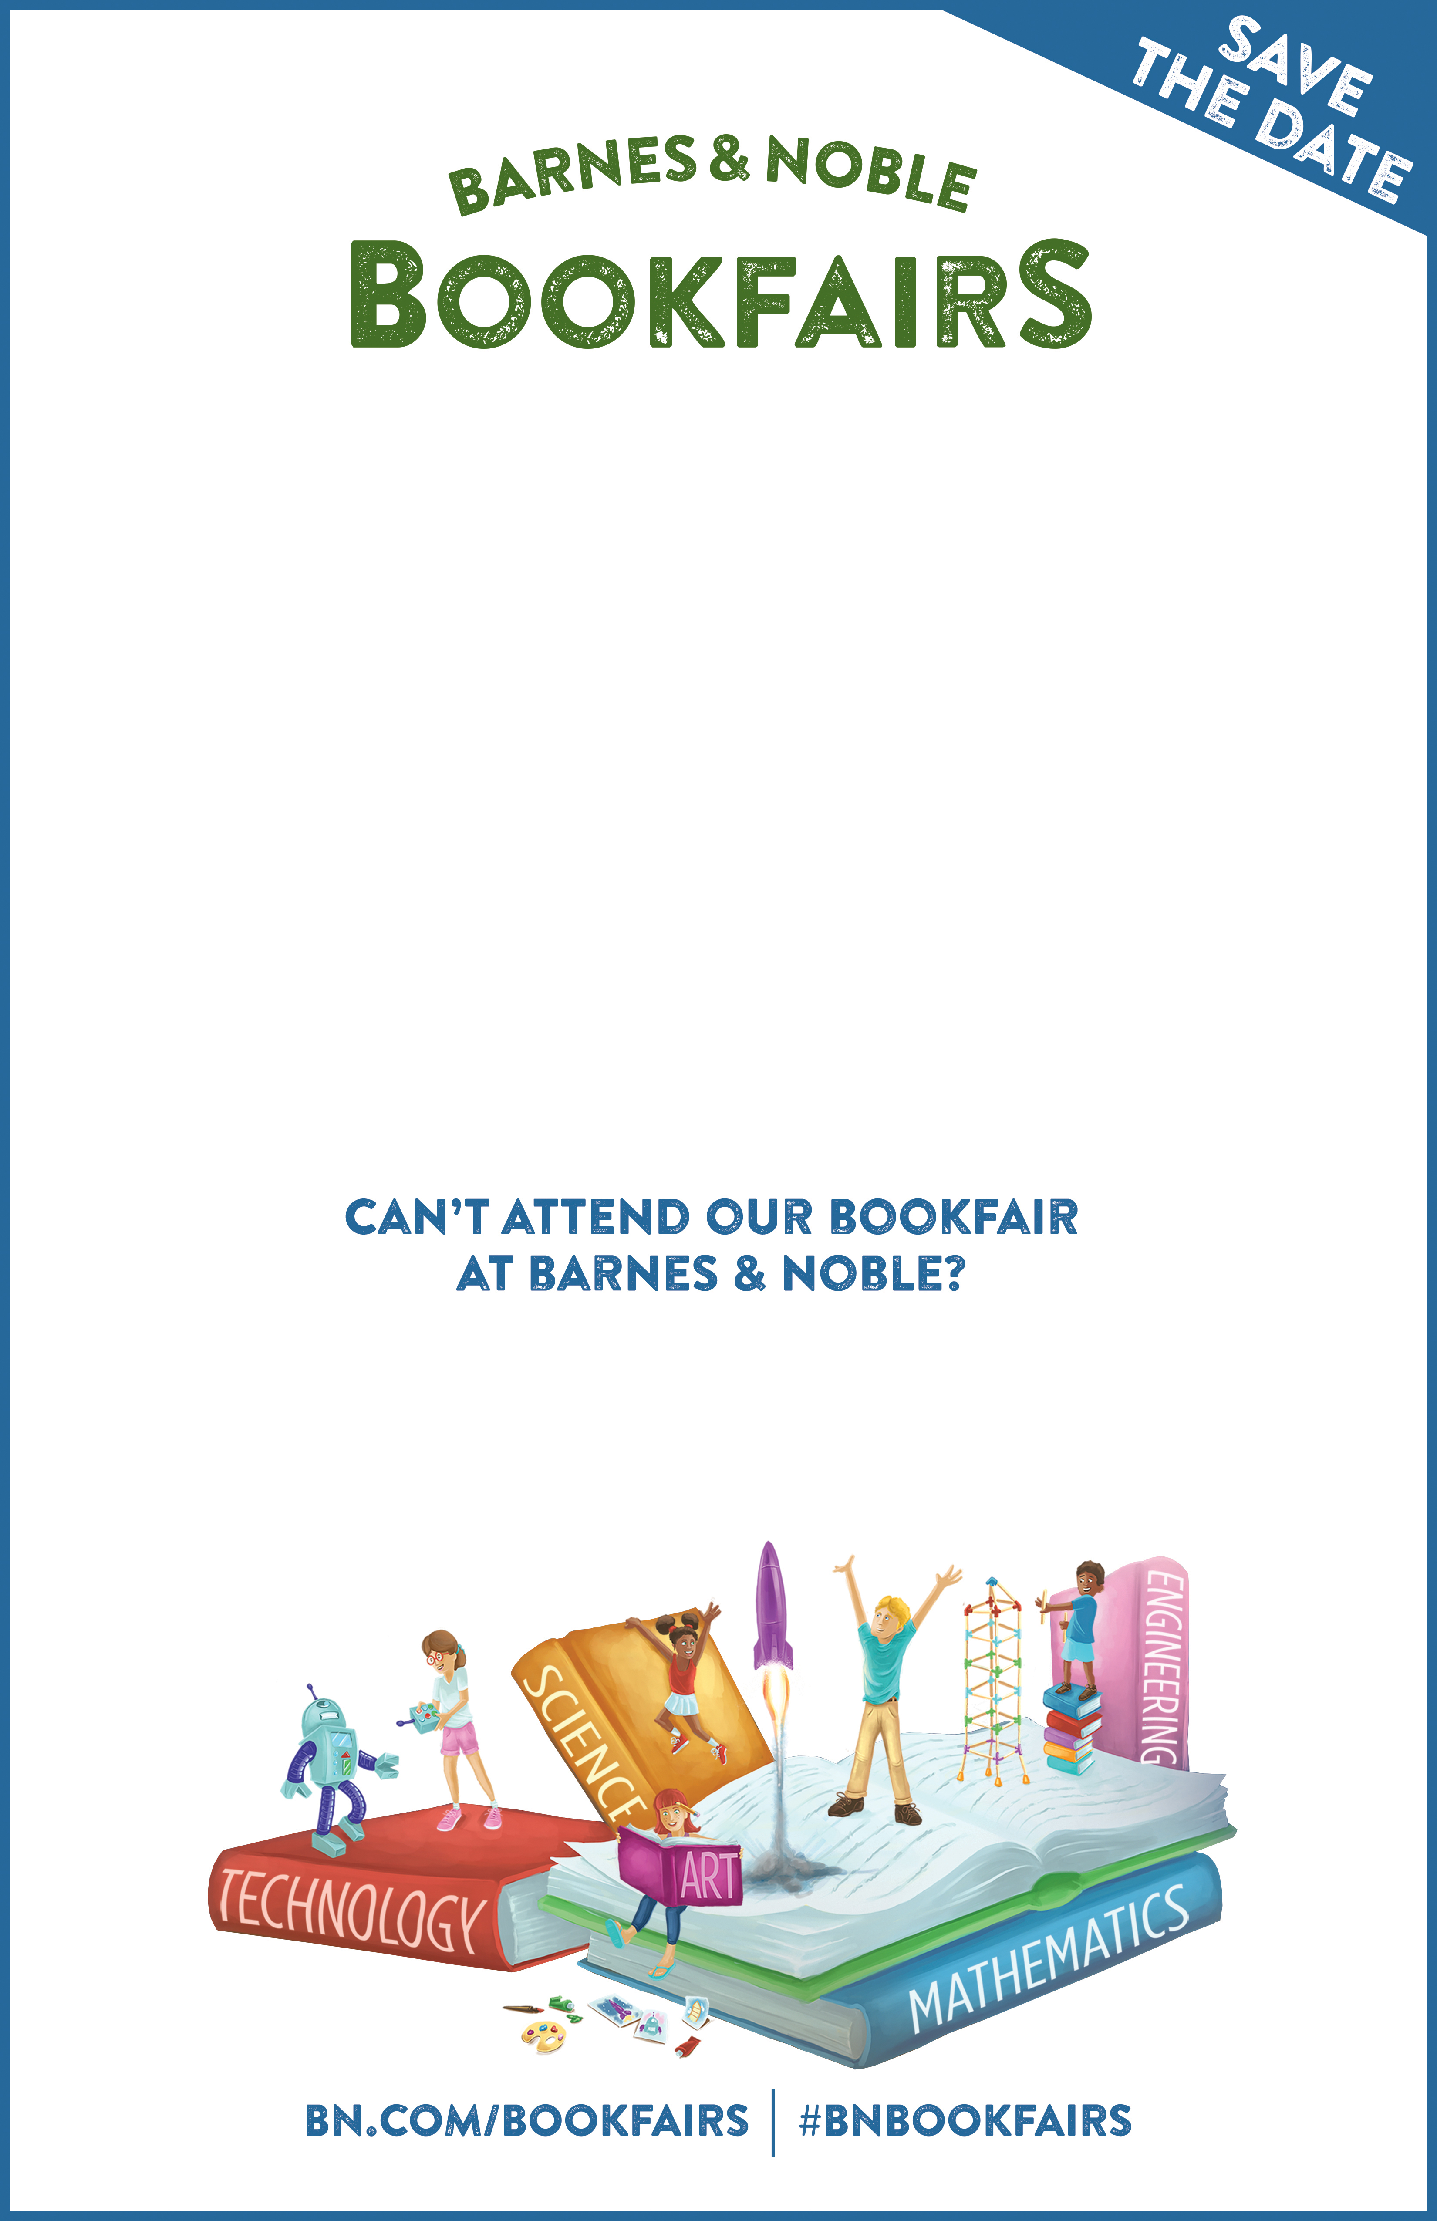

Visit **BN.COM/bookfairs** to support us online from XX/XX/17 to XX/XX/17

by entering Bookfair ID XXXXXXXX at checkout.

A percentage of your Barnes & Noble purchases will benefit our school/organization.

**School/Org Name**

**Day, Date, Time**

**Barnes & Noble Location**

**Street Address, City Name**

**Add School/Org specific copy here, e.g.:**

• See our school choir perform!

• Get your picture taken with a costumed character.